**ENERGY CONFERENCE:**

**Navigation Guidelines:**

1. From the index.html page you need to click on the Energy Conference tab in the nav bar to navigate to the energy conference site.
2. The EnergyConference.html is the home page and this page has **About Us, Keynote Speakers, Agenda, Sponsors**, **Registration, Blogs .**
3. When you click on the tabs like **About Us, Agenda, Sponsors** it will take you through the respective **div id’s** in the home page.
4. The **Panels** tab has different li’s like Sustainable buildings, Thermal Power, Clean Energy etc and each of these will take you to the respective pages which gives you details about the panel speakers who will talk on the specific topics.
5. **Organizing Team** tab gives us an idea on the people who are there in the department with a google form to which users can subscribe to the news letter.
6. **Event Location** tab gives us an idea on the events along with the location in the form of a map.
7. **Registration:** User Registration form which has Angular js validations.
8. **Blogs:** Blogs page is where users can post articles on posts.

**Features:**

**Boostrap** was used for the subsequent web pages. Every code was compressed inside the container class.

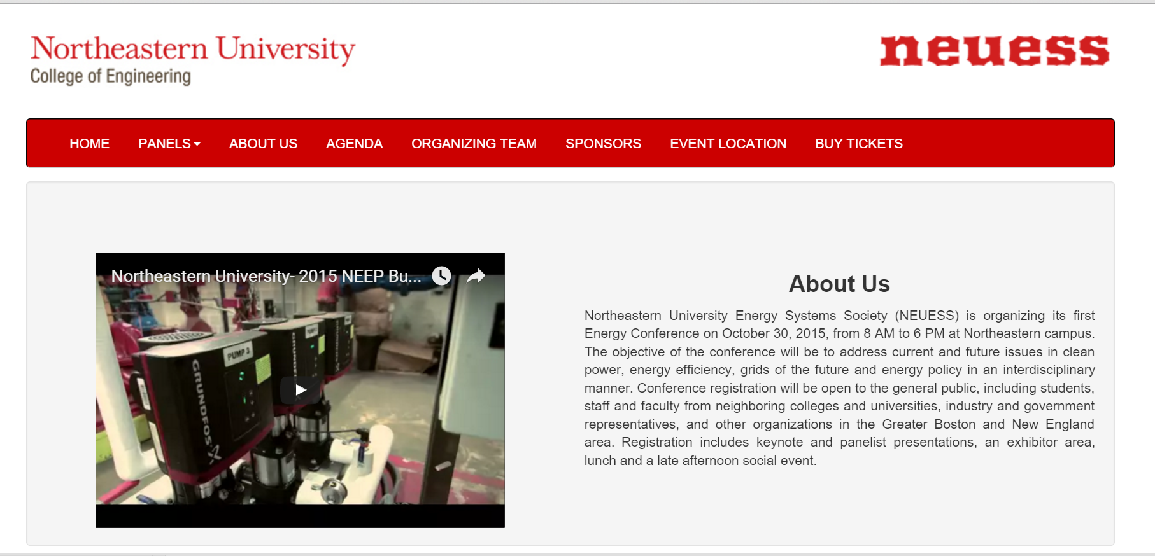

In the above section I had made use of a **Responsive navbar** with the northeastern energy systems society **Icon logo.**

**HTML5 Video feature** has been added this follows the column layout and the video and About us take up 6 out of the total 12 column span.

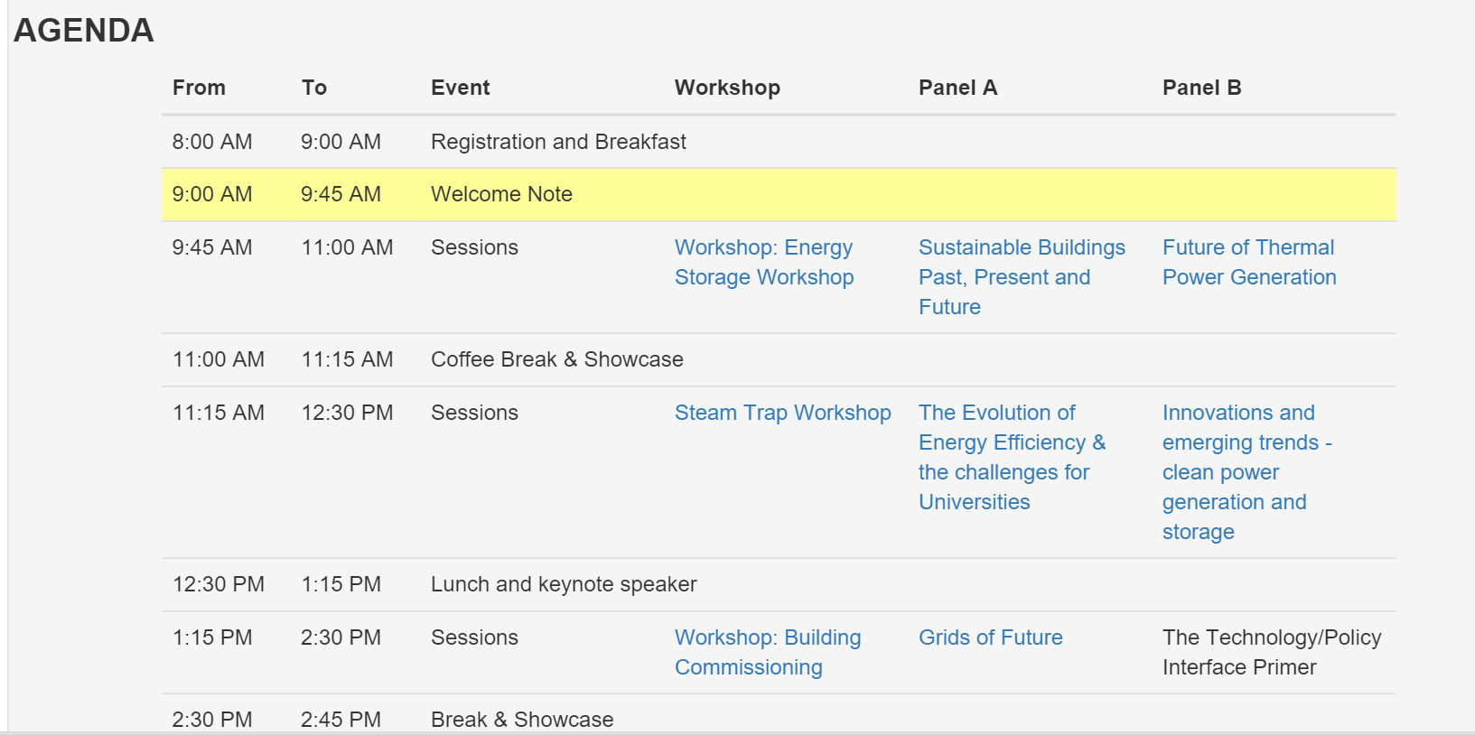

**Responsive table** focuses on the **AGENDA** and links have been given to the panels using href

This particular table was replaced **with tabs and accordion** which has details on timings,different worshops and the links will take you to the respective panels.

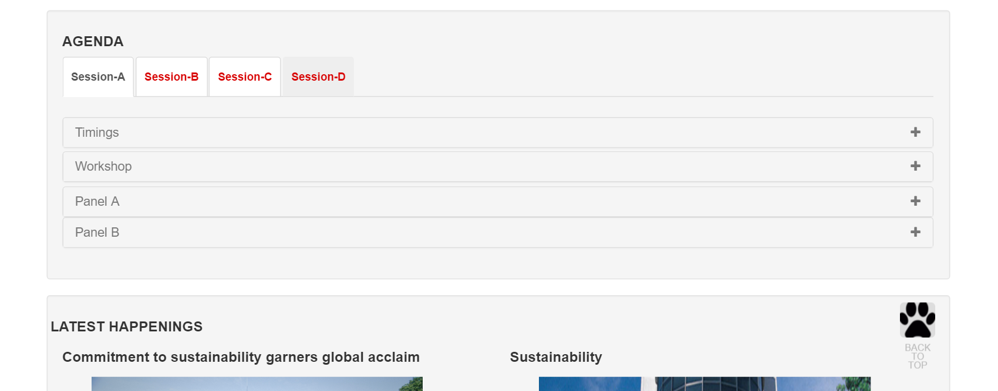

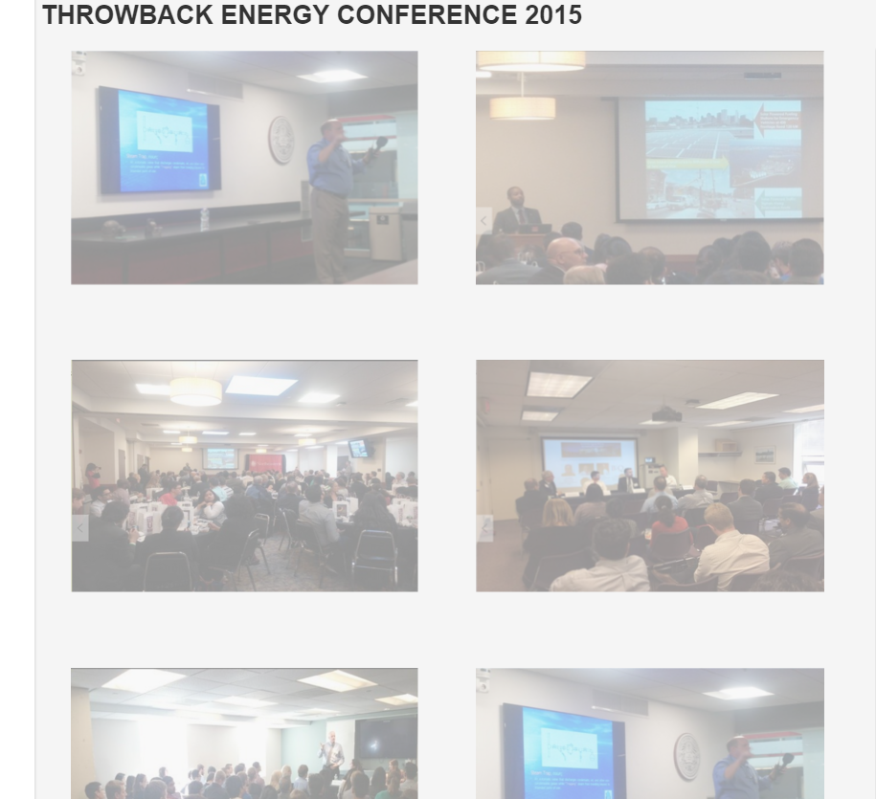

**Hover effect** was given using the property of **opacity from** 0.4 to 1.0

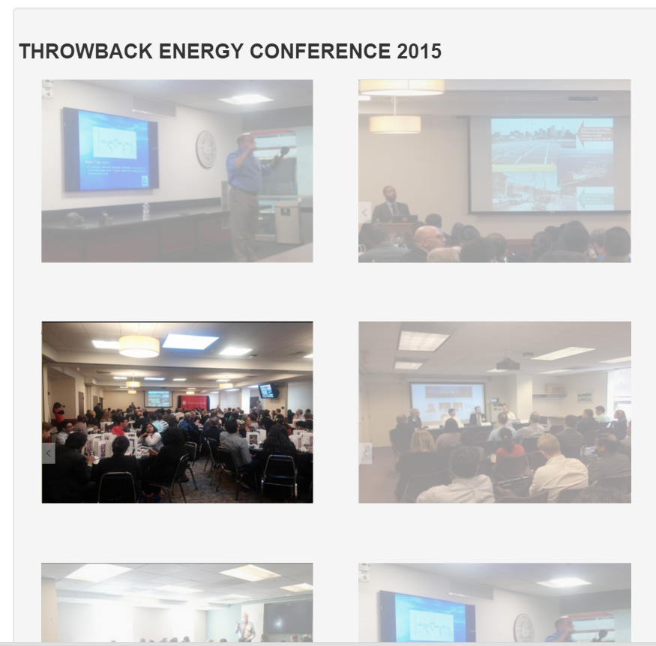

.imageclass img {

opacity: 0.4;

filter: alpha(opacity=40); /* For IE8 and earlier */

}

.imageclass img:hover {

opacity: 1.0;

filter: alpha(opacity=100); /* For IE8 and earlier */

}

**Autoscroll feature** which will take you to the top.

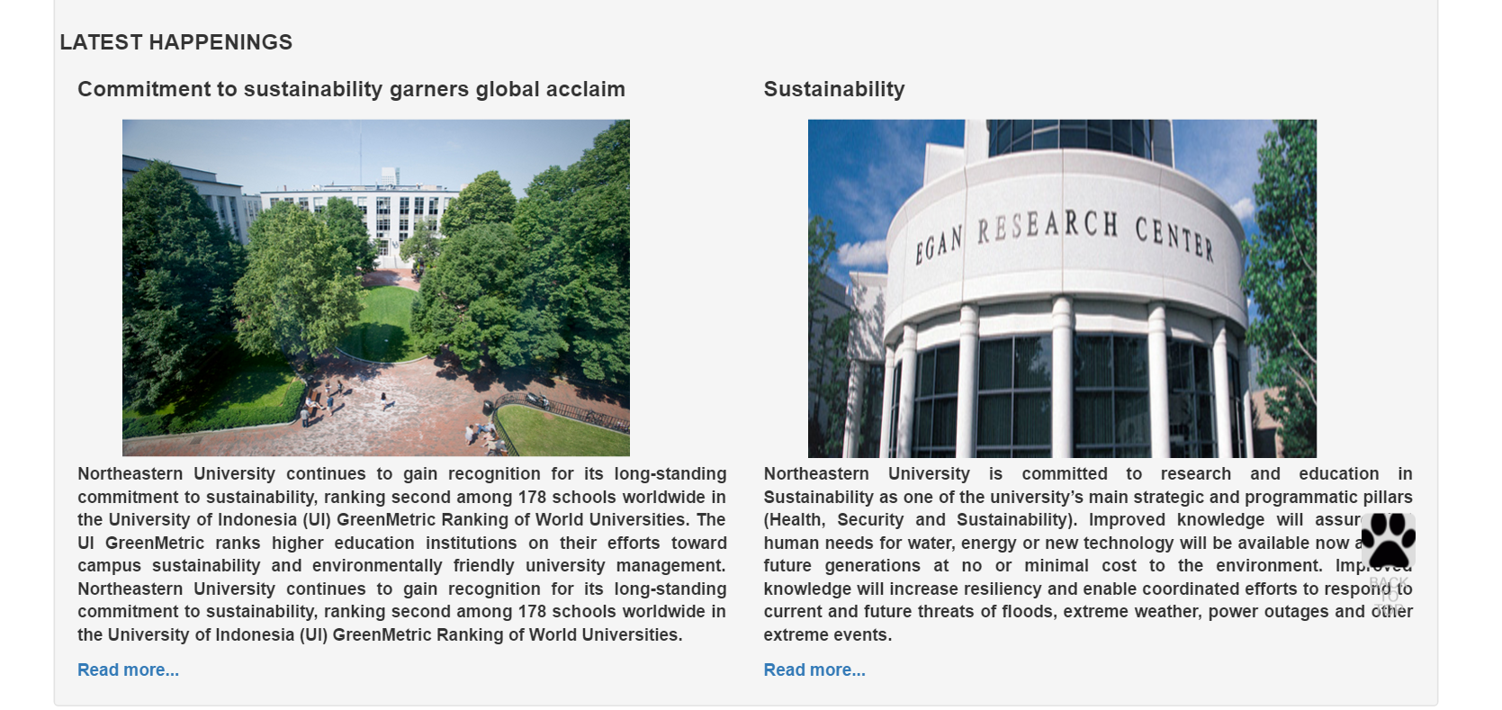

**Read more and Read less feature** which makes you see more and less content.

**Jquery collapsible** was used to do this.

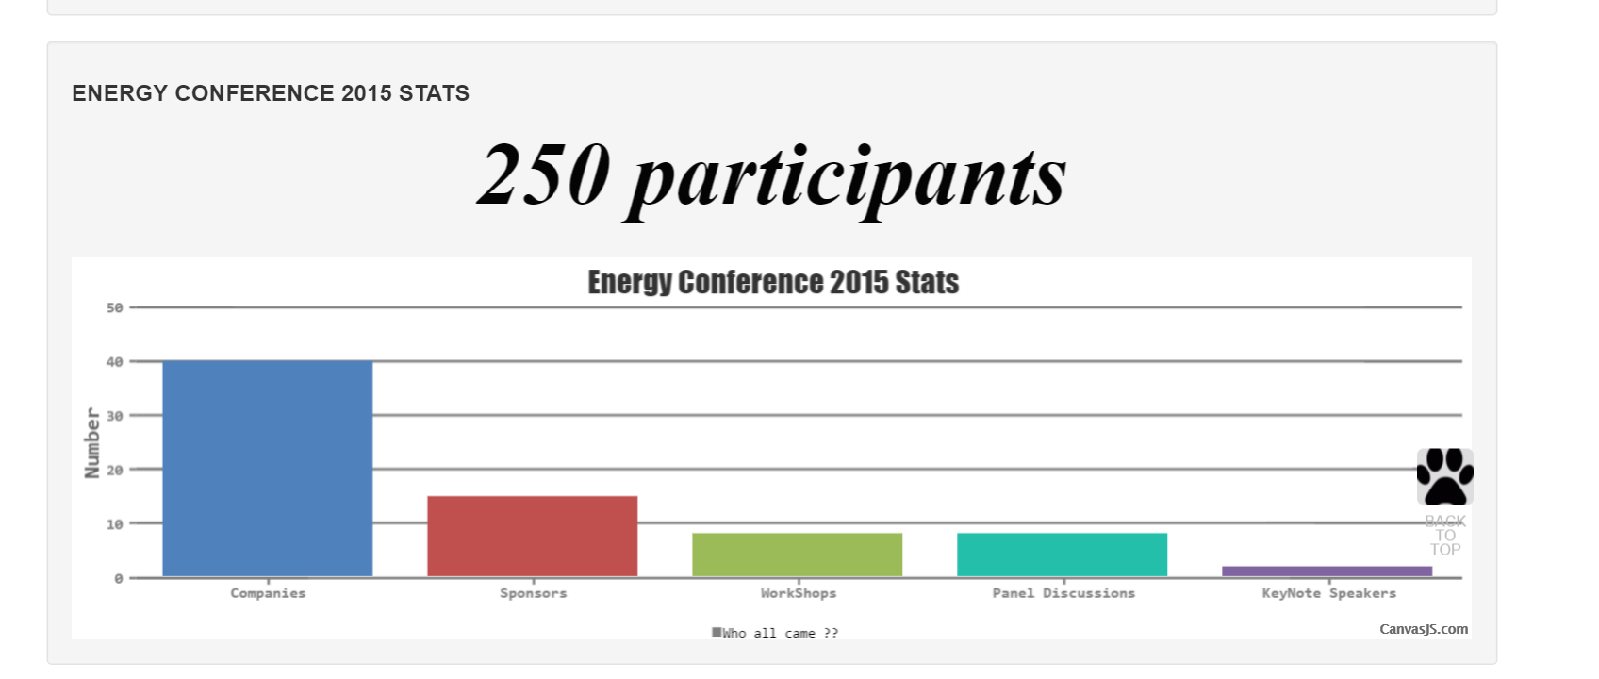

This above chart shows the stats of last year energy conference which shows the number **Company,Workshops,Panel Discussion,Keynote Speakers**.

**Canvasjs.plugin** is used for the above feature and the entire chart is in **HTML5 canvas feature.**

**jQuery Animate feature and a div which replaces that with a different div.**

$(".imageclick").click(function(){

$(".imageclick").animate({left: '630px'},2000);

changeImage();

$("#show1").hide();

$("#show2").show();

});

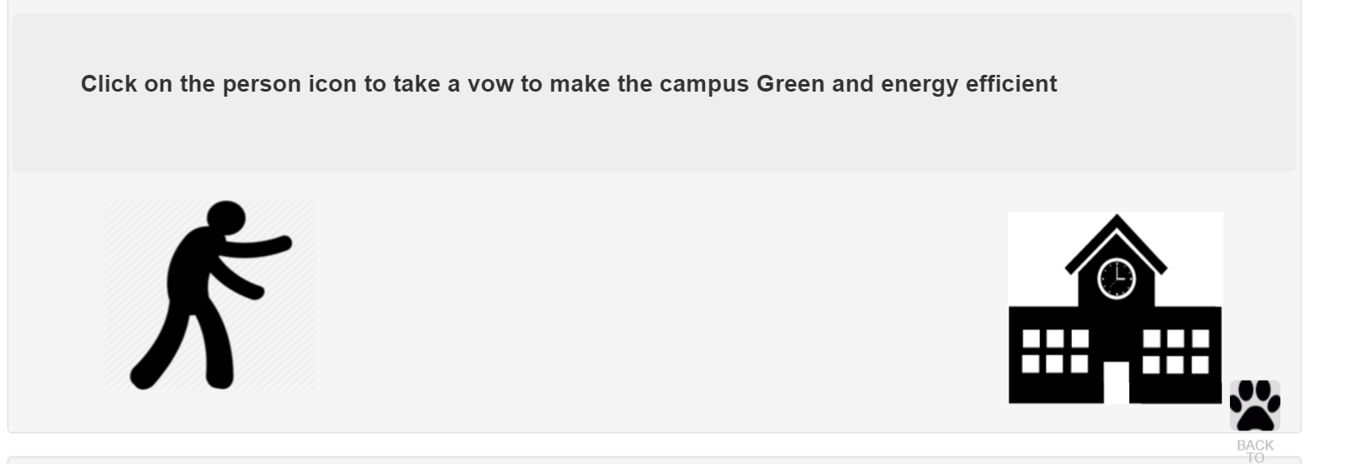

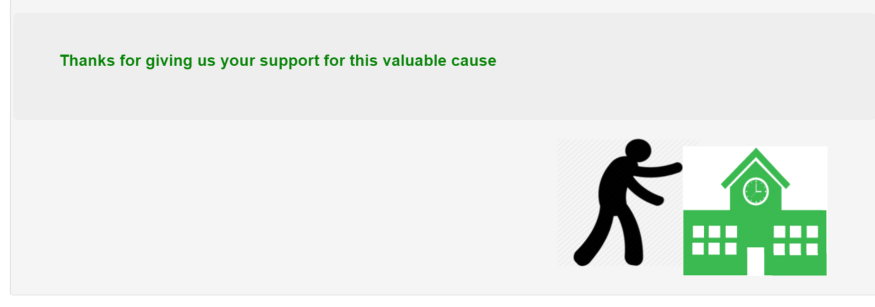

**CSS3 TRANSITION FEATURE**

**CSS3** transition when hovered over the browser features which are compatible with different browsers has been taken care off.

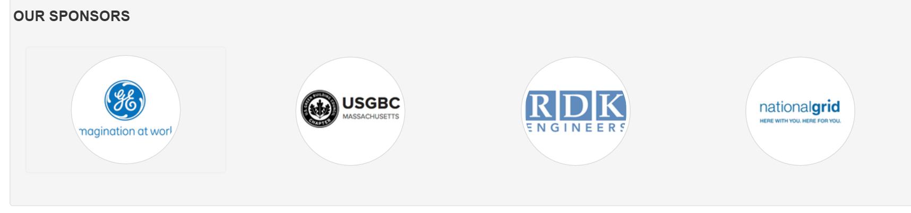

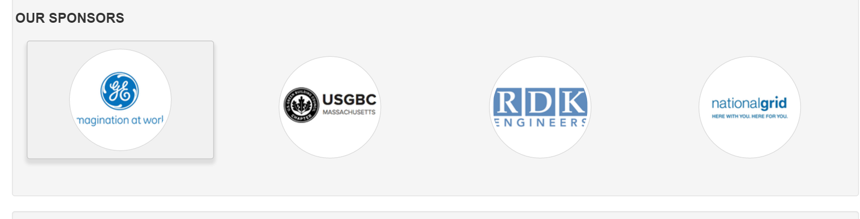

**ORGANIZING TEAM**

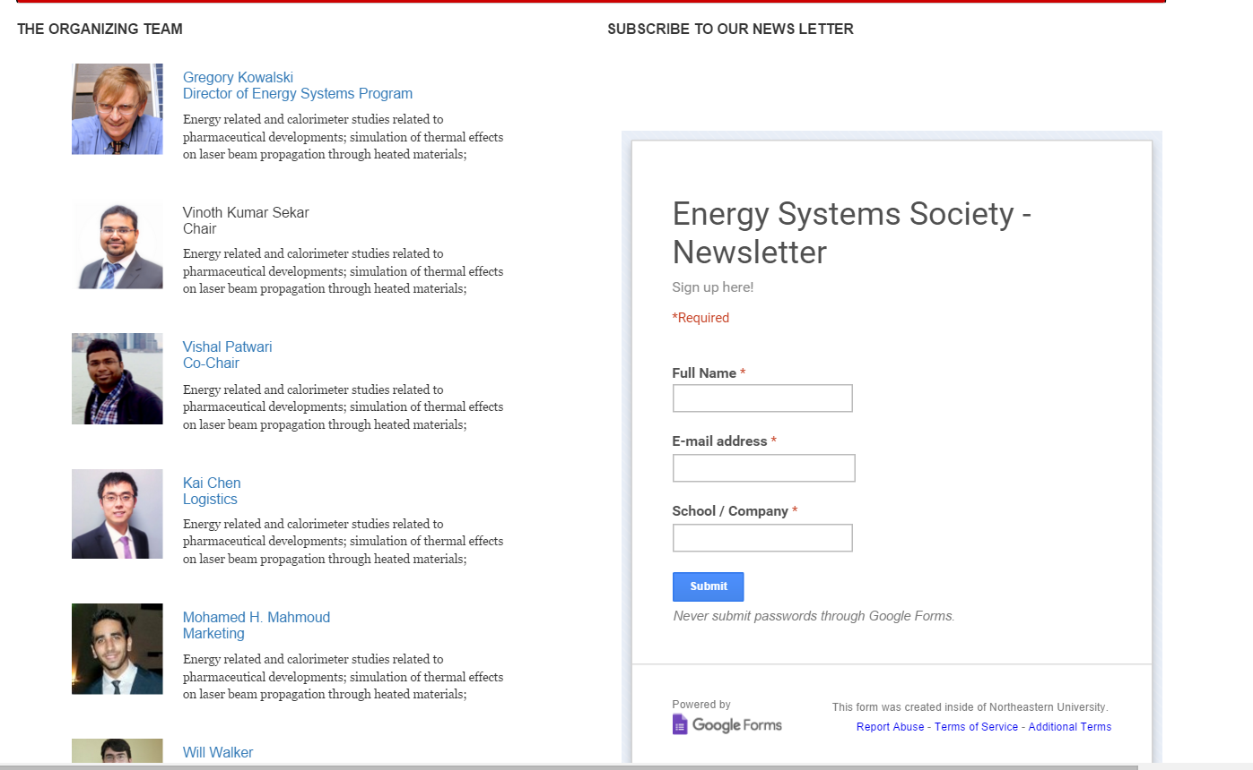

If the user clicks on any of the persons name it would land into the particular persons **linked in** page.

It also has a google form which helps the user to subscribe to the news letter

**CSS3 Box shadow property for the image**

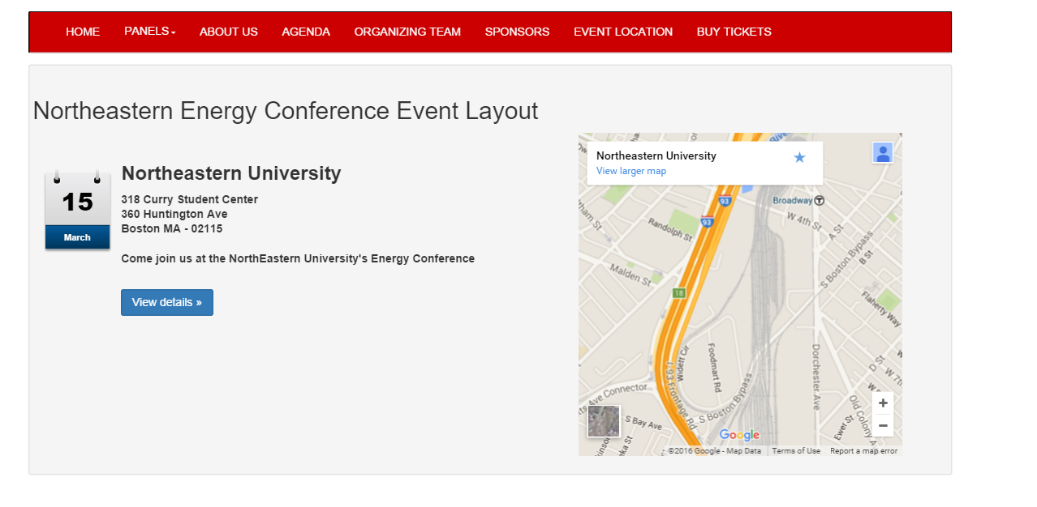

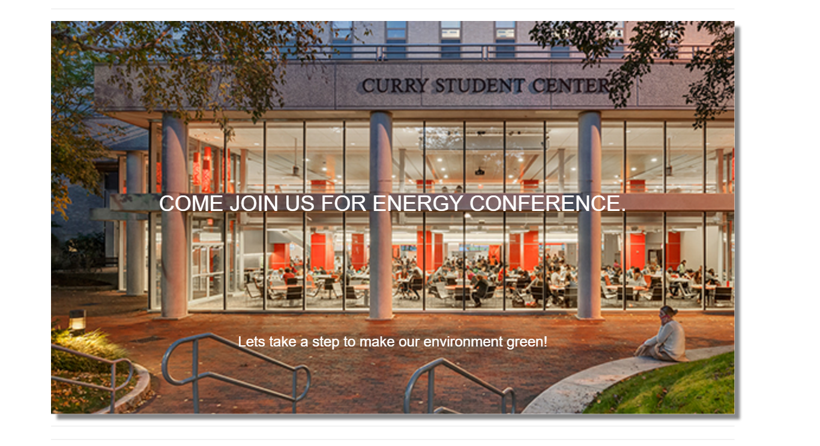

**CSS3 transition & Carousel**

Initially one of the carousel’s will be active with opacity of 1 and it changes every 4 seconds as the carousel has the timer property.

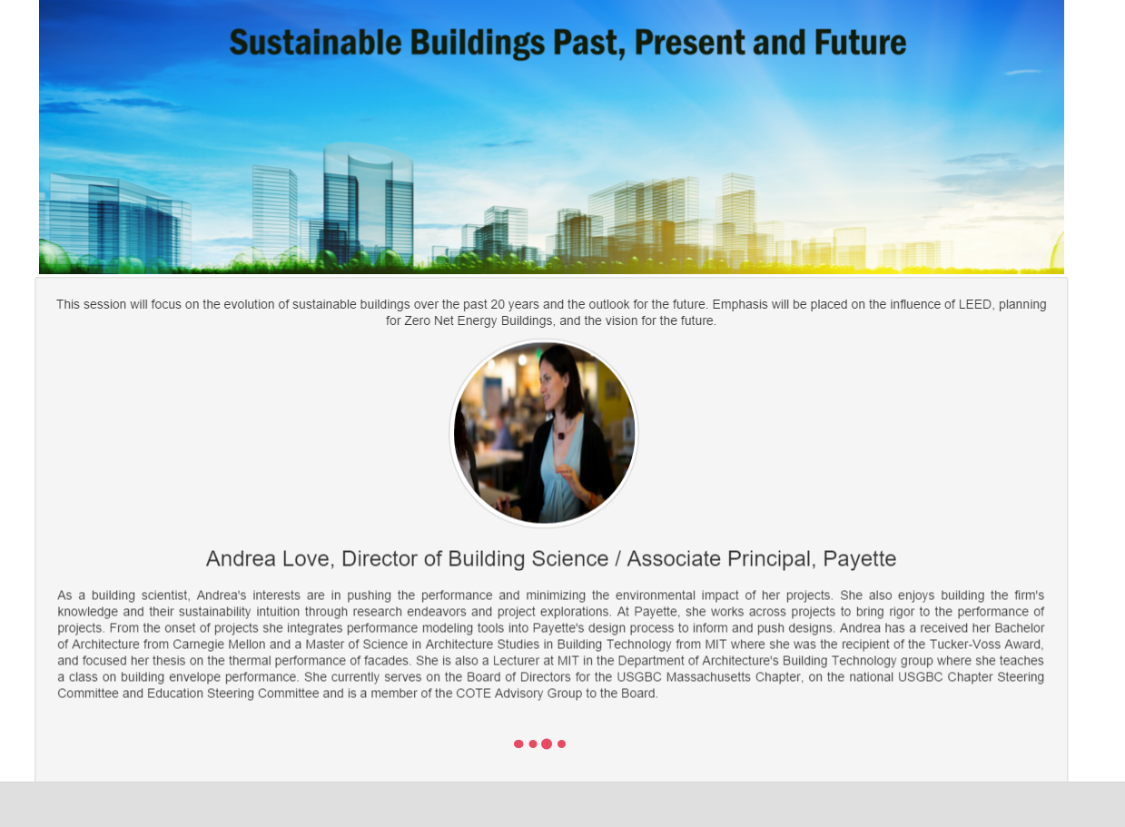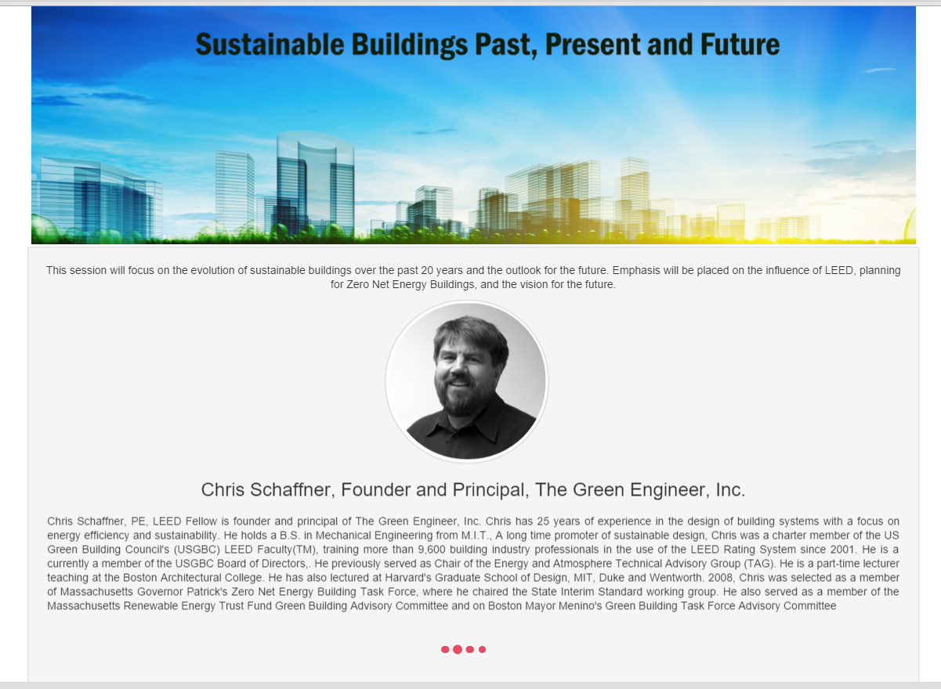

**USER REGISTRATION FORM – ANGULAR JS**

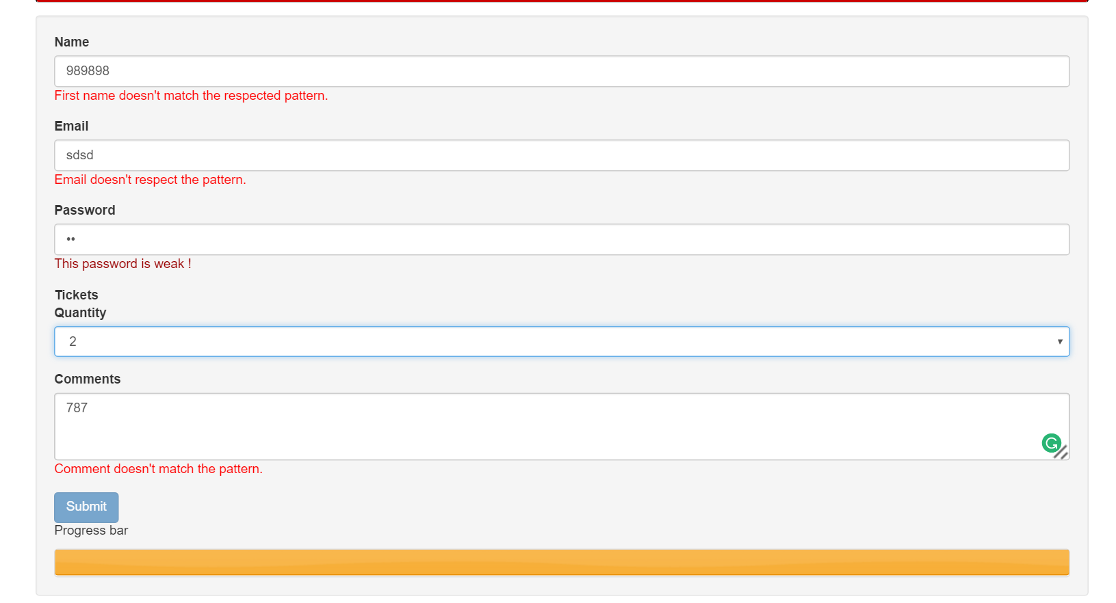

* **Registration form** which has **Angular JS validations** in it.
* **Password strength defined by an ng-directive and Progress bar** which shows progress of the form

var todoApp = angular.module('TodoApp', ['firebase']);

todoApp.controller('TodoCtrl', ['$scope', '$firebaseArray',

function($scope, $firebaseArray) {

var todosRef = new Firebase('https://teamtododemo.firebaseio.com/');

$scope.todos = $firebaseArray(todosRef);

$scope.addTodo = function () {

var timestamp = new Date().valueOf();

$scope.todos.$add({

id: timestamp,

name: $scope.todoName,

status: 'pending'

});

$scope.todoName = "";

};

$scope.removeTodo = function (index, todo) {

if (todo.id === undefined)return;

$scope.todos.$remove(todo);

};

$scope.startTodo = function (index, todo) {

if (todo.id === undefined)return;

todo.status = 'in progress';

$scope.todos.$save(todo);

};

$scope.completeTodo = function (index, todo) {

if (todo.id === undefined)return;

todo.status = 'complete';

$scope.todos.$save(todo);

};

}]);

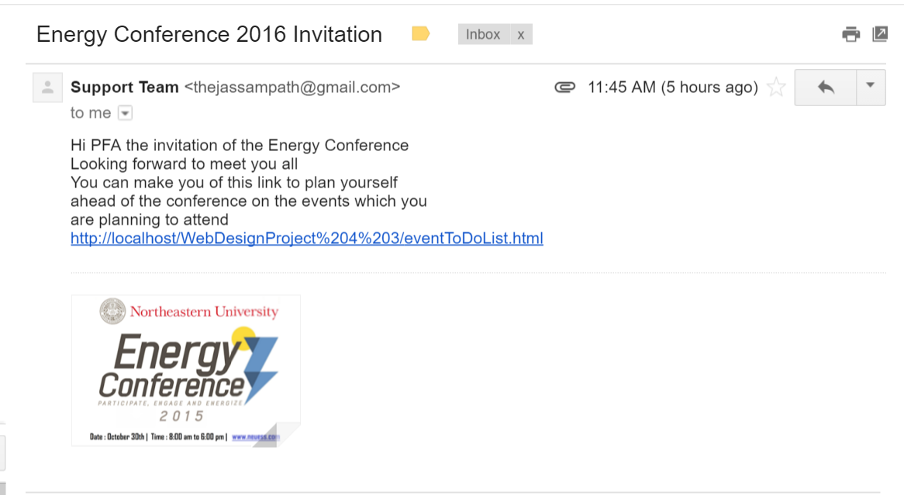

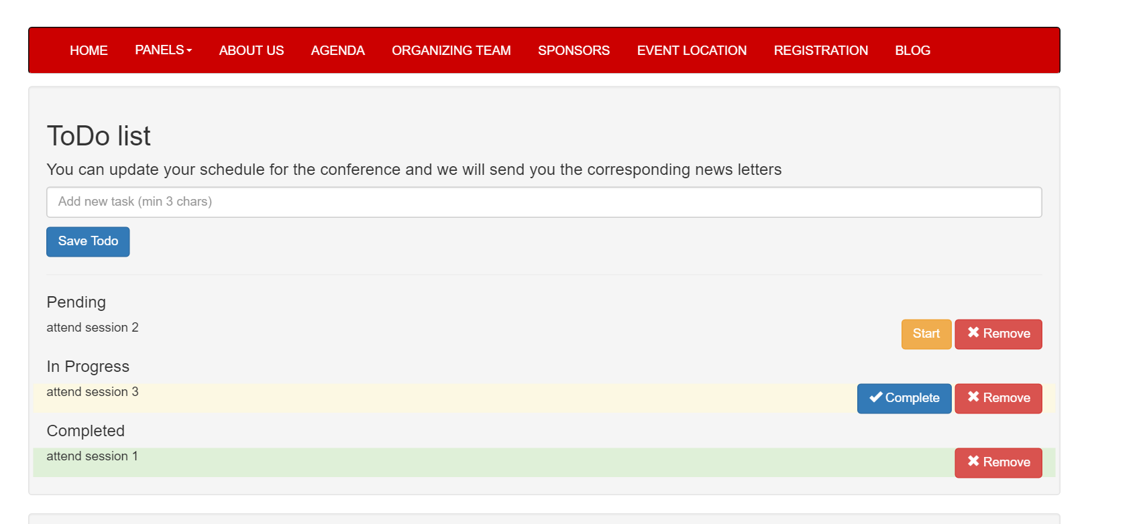

**Todolist** which has Start, Remove and Complete

This is done using Angular FireBase.

* Password strength field is determined using directives.
* **Email with an attachment goes to the registered user**.
* User also gets **todo** list as a html link where he can **update , delete or create his plan** ahead of the conference which was designed using Angular js.
* jQuery tooltip feature is used here.

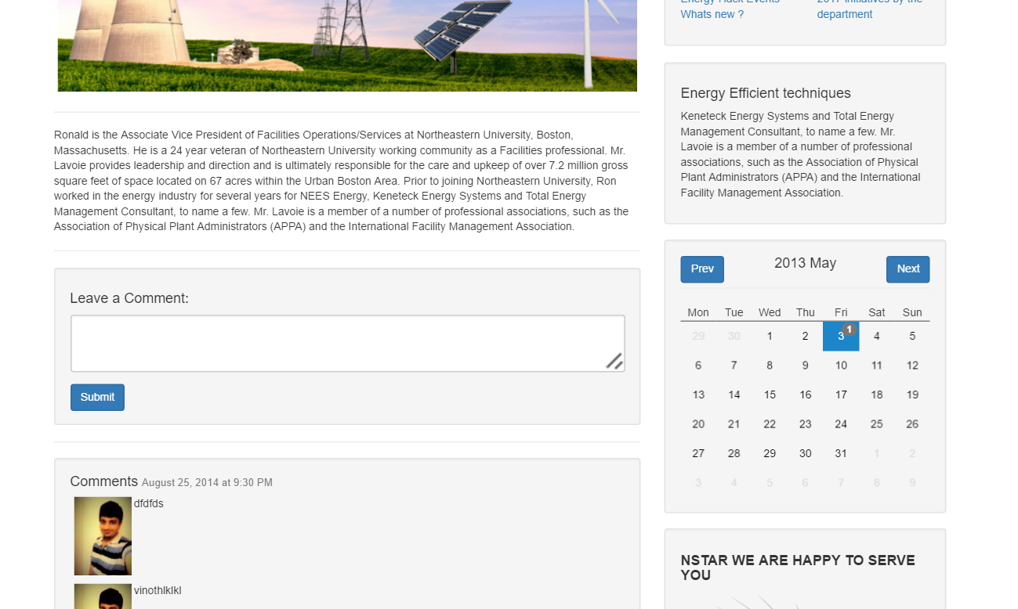

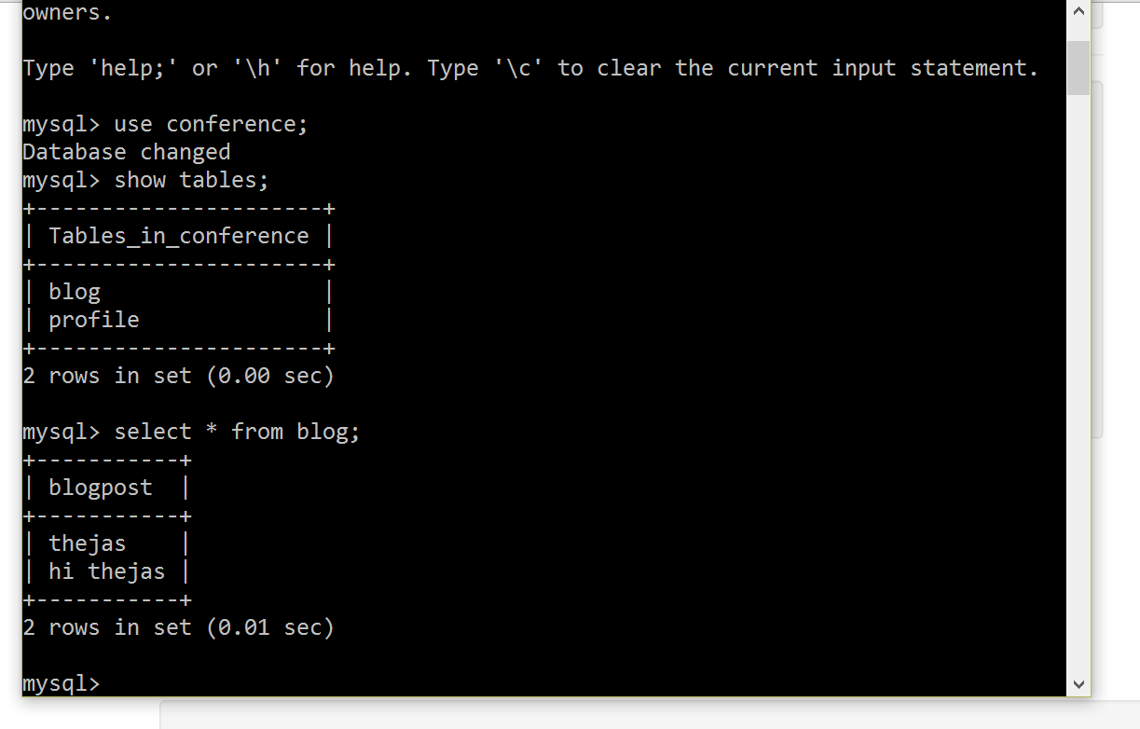

MYSQL terminal which shows database and tables

Blog page is used to post comments on the existing blogs which has image with content in it.

* **jQuery responsive calendar a plugin** which I had used to show the calendar.
* **http ajax call i**s made to the backend to fetch the data from the blog table.

var mainApp = angular.module("mainApp", [])

mainApp.controller("blogController", function($scope,$http) {

$scope.getItem=function(){

$http.post("angulartest.php").success(function(data){

$scope.blogpostfromtable = data;

$scope.media={imagepath: "thumb.jpg"};

});

};

});

This is the code snippet for that

**TECHNOLOGIES**

HTML5, CSS3, Javascript, jQuery, Angular JS, MYSQL